Project Proposal (KhammTheBuilders)

Project Title
IRBS (IBA Room Booking System)

2. Project Type
Web Application
☐ Mobile Application
☐ SaaS Platform
☐ ERP/CRM Customization
☐ Integration Project
☐ Other: [Specify]

3. Stakeholders & Users
Role | Description / Responsibility
Stakeholder 1: Developers | Build frontend, backend, and database.
Stakeholder 2: IBA Management / Administration | Oversee system usage and data accuracy.
End User Type 1: Program Office | Adds buildings and assigns building incharge. Hardcoded login.
End User Type 2: Building Incharge | Manages rooms in their assigned building (create rooms, update availability, view bookings).
End User Type 3: Students | Searches for rooms and books available rooms.

4. High-Level Scope
Feature / Module | Description
Room Booking System (Core Feature) | Students can view available rooms (classrooms or breakout rooms) and book them based on date, time, and building.
Building Management (PO) | PO can add new buildings, and assign building incharge.
Room Management (Building Incharge) | Building incharge can add/update/delete rooms for their building and manage schedules.

5. Out of Scope
- Chatbot
- Communication between students
- Complains module
- Faculty directory
- Lost & found

6. Trello Board Link

https://trello.com/invite/b/68d0322b9d53c11fe3015732/ATTI15c08490440072a8ffe4ef5deb8e31d90303723B/my-trello-board

7. Project Overview

7.1 Tech Stack
Layer | Technology
Frontend | React.js (modern SPA framework), Bootstrap, Figma (UI/UX wireframes)
Backend | Node.js (Express.js) for server-side logic and REST APIs
Database | Oracle Database using SQL Developer
Deployment | (deployment not yet decided) AWS (EC2, RDS, S3) or Heroku for backend hosting, Vercel for frontend deployment
Tools/Integrations | SMTP (user authentication), GitHub (version control), Trello (Agile project management), Postman (API testing)

7.2 Architecture
The system follows a 3-tier architecture:
1. Client Layer (Frontend)
- Built using React.js
- Users interact with interfaces based on their role:
- PO Dashboard (add buildings, assign building incharge)
- Building Incharge Dashboard (manage rooms & view bookings)
- Student Portal (search and book rooms)
2. Application Layer (Backend)
- Node.js + Express
- Implements:
- Login/registration APIs
- Building and room management APIs
- Booking APIs
3. Database Layer
- Oracle SQL Database accessed via SQL Developer
- Stores tables such as:
- Users
- Buildings
- Rooms
- Bookings
- Building_Incharge
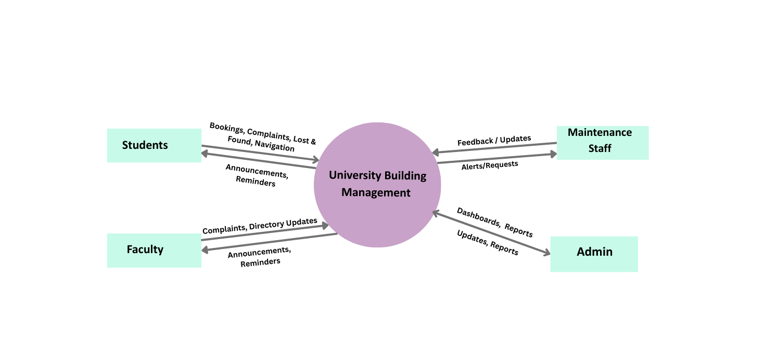
Context Diagram:

